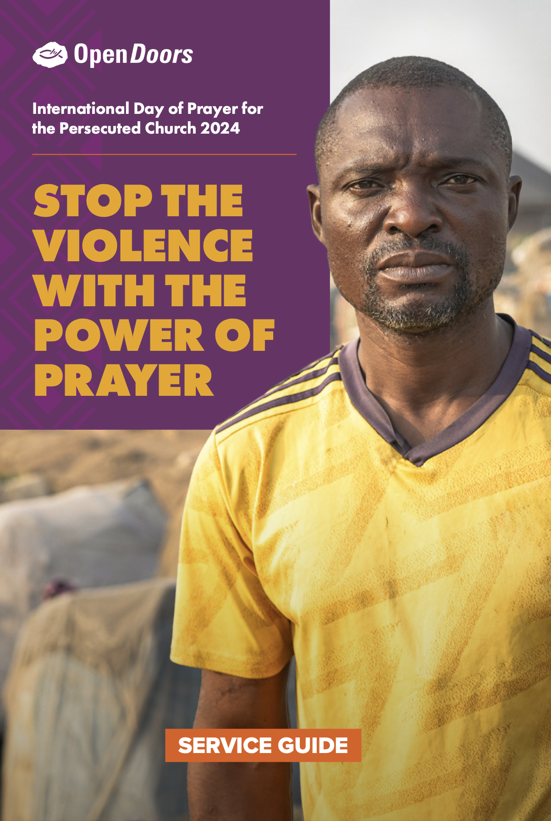

**STAND WITH YOUR PERSECUTED FAMILY**

***IN PRAYER***

Church leaders and Christians in Sub-Saharan Africa are calling you…

Calling you and your church to join with them.

To stand as one with your persecuted family.

To rise up against violent persecution.

*To pray.*

On the International Day of Prayer for the Persecuted Church, will you answer their call? Because your prayers have tremendous power to stop the violence and start the healing.

We’ve produced resources to help you and your church pray, and this short guide will help you plan your service. If you need more information, please get in touch at [enquiryhk@od.org](mailto:enquiryhk@od.org) or call +852 3525 0820.

Thank you so much.

**“The earnest prayer of a righteous person**

**has great power and produces wonderful results.”**

JAMES 5:16 NLT

**BACKGROUND**

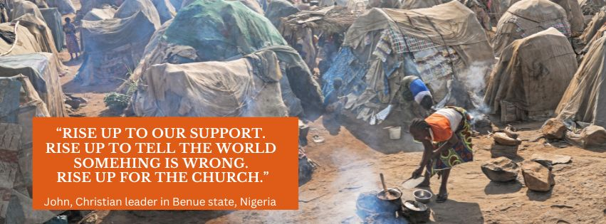

**16M CHRISTIANS DISPLACED**

**BY CONFLICT AND VIOLENCE**

Violent persecution in Sub-Saharan Africa is unprecedented – and it is devastating people’s lives.

Not only are Christians brutally murdered, attacked and kidnapped, millions are being driven from their homes. Forced by Islamist terror groups to leave their ancestral land and relocate their families to tiny tents in makeshift refugee camps.

In the camps, every day is a struggle to survive. There’s never enough food, too few toilets, and the sun beats down with unbearable heat. Children have no school. Families are grieving and traumatised. People feel hopeless.

*For years, displaced believers have lived like this*. It’s no wonder they feel the world has abandoned them.

**“Then you will call, and the Lord will answer;**

**you will cry for help, and he will say: Here am I.”**

ISAIAH 58:9

Insecurity and instability are creating a housing crisis, an education crisis, a healthcare crisis, a refugee crisis.

Your prayers are part of the answer. Your church can join the African church to stop the violence and start the healing – *through prayer*.

**YOUR SERVICE**

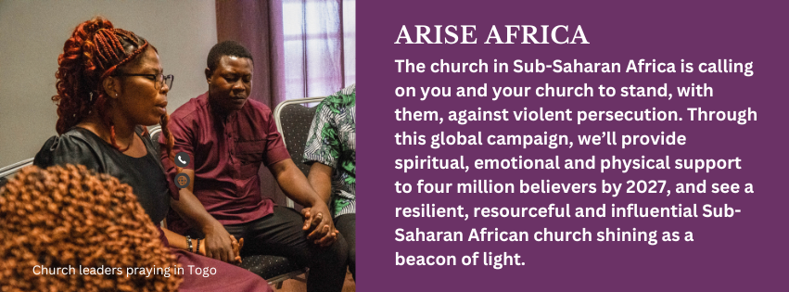

You can hold a special service for the persecuted church in Sub-Saharan Africa, or set aside a prayer slot in your usual service. Whatever your plan, Open Doors can help.

Our suggested running order for your International Day of Prayer service or slot:

1. Play the five-minute **video** featuring [stories of Christians from Nigeria](https://youtu.be/I5Fj3whrKas). Also you can show [Pastor Barnabas](https://youtu.be/3oDUp1L8sN4) and [Pastor Soré’s story](https://youtu.be/o-QrS5pUK9g).
2. **Introduce** the International Day of Prayer for the Persecuted Church, and share why our prayers are so vital. You can use the sermon guide provided.
3. Lead the congregation in **prayer**. You can use the PowerPoint slides provided or print out information for a smaller group.
4. Run the whole-church **activity** (details on the next page) to encourage your community to reflect and pray.
5. [Take a collection](https://www.opendoors.org.hk/en-US/getinvolved/give/arise-africa/) to support your persecuted brothers and sisters in Sub-Saharan Africa.

**WHOLE CHURCH ACTIVITY**

**Create a Tree of Prayer and Justice**

Encourage everyone to create a Tree of Prayer and Justice, to help you pray for the persecuted church in Sub-Saharan Africa.

Here’s what you need to do:

1. Get creative, and construct a tree in your church. You could gather branches and arrange them, build a cardboard tree, put up a picture of a tree on a display board, or think outside the box!
2. Use the template at the last page to create prayer leaves. Make photocopies so people can cut out their own leaf.
3. Encourage people to think about their persecuted brothers and sisters in sub-Saharan Africa, and get everyone to write a prayer or Bible verse on their leaf.
4. Attach everyone’s leaves to your Tree of Prayer and Justice.
5. You can share a picture or video of your tree with us at [enquiryhk@od.org](mailto:enquiryhk@od.org)

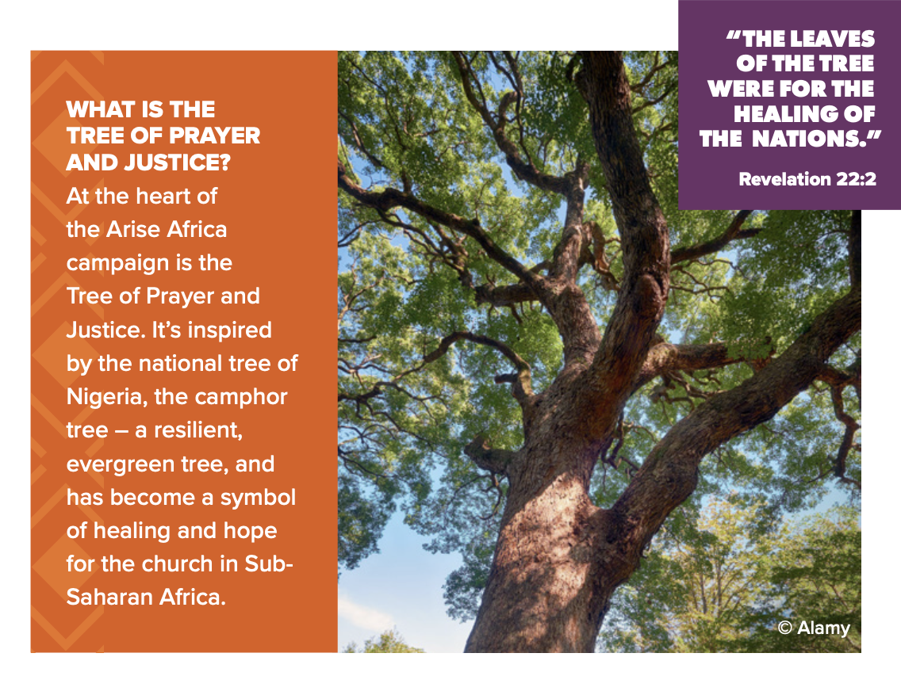

**Call for change**

Our aim is to join the African church to raise a million prayers and signatures. Encourage your church members to add their names to the global petition. visit the Arise Africa website at [leavesofhealing.org/petition](https://leavesofhealing.org/petition) .

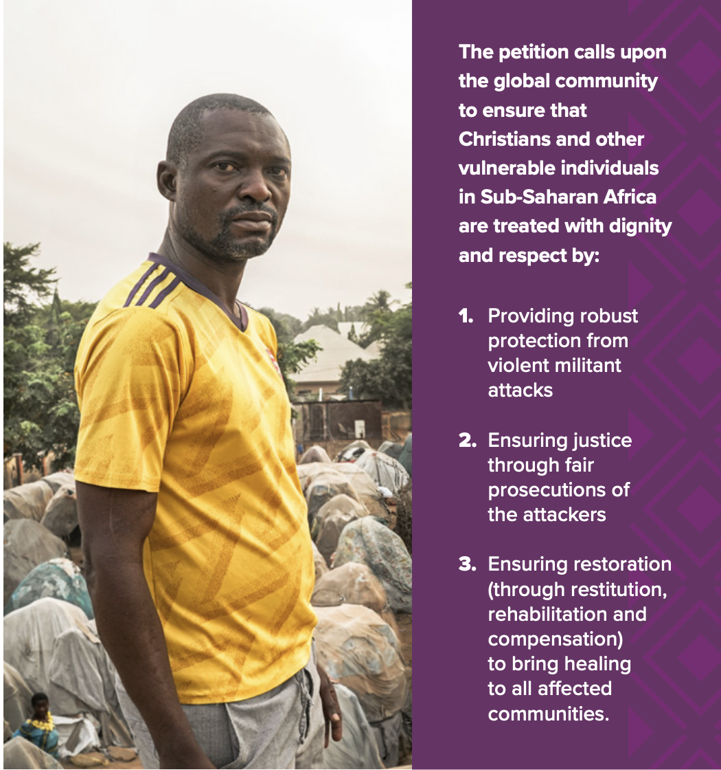

**Spread the word**

Encourage everyone to get out their smartphones, visit the Arise Africa website at [leavesofhealing.org/petition](https://leavesofhealing.org/petition), and post about it on social media. The more we share the campaign, the more our persecuted brothers and sisters will know they are not alone.

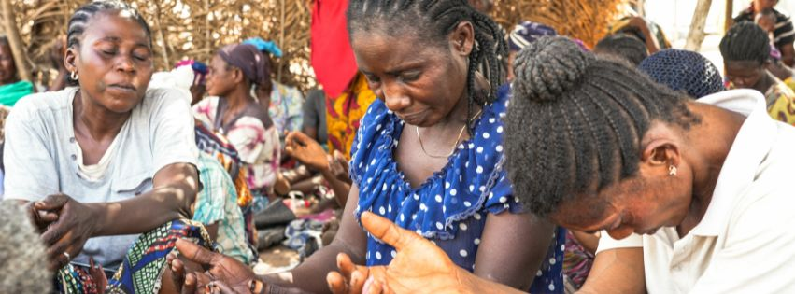

**How to pray**

1. Pray for violence to end. Ask God to speak to the men of violence and draw them to peace.
2. Pray for political leadership. Pray for the will, strategy and resources to put an end to impunity for violent persecutors.
3. Pray that international agencies will wake up to the religious dimension of this assault on Africa’s Christians.
4. Pray for leaders of the Church in Sub-Saharan Africa, that they will have wisdom, guidance and resources.
5. Pray for your brothers and sisters in Christ, as they suffer day after day in refugee camps. Ask the Father to meet their needs, and deliver them from evil.
6. Pray for those who mourn, that God will meet them in their sorrow, to comfort them and strengthen faith.
7. Pray the Church in Sub-Saharan Africa will persevere, and grow in resilience, endurance, determination and faithfulness. Pray the Church will shine as a beacon of God’s light.
8. Ask God to help you, as you watch and pray, and stand with your persecuted family in their suffering and pain.

**Your Church’s response**

**Give: support financially**

Please could you hold a collection or send a church [gift](https://donation.opendoors.org.hk/?lang=en), to stop the violence and start the healing in Sub-Saharan Africa?

* **Every HK$170** could provide emergency shelter to a Christian driven from their home.
* **Every HK$280** can sustain a displaced believer with food, clothing and medical care.
* **Every HK$600** could provide a month of education to a displaced child, to give them a future.

**Act: sign the petition**

Encourage church members to sign the petition. Encourage people visit [leavesofhealing.org/petition](https://leavesofhealing.org/petition) to add their name and prayer online.

**Commit: keep in touch**

Encourage your community to sign up to hear from Open Doors by visiting [opendoors.org.hk](http://www.opendoors.org.hk). We’ll send weekly emails with inspiring stories, as well as news and prayer points.

