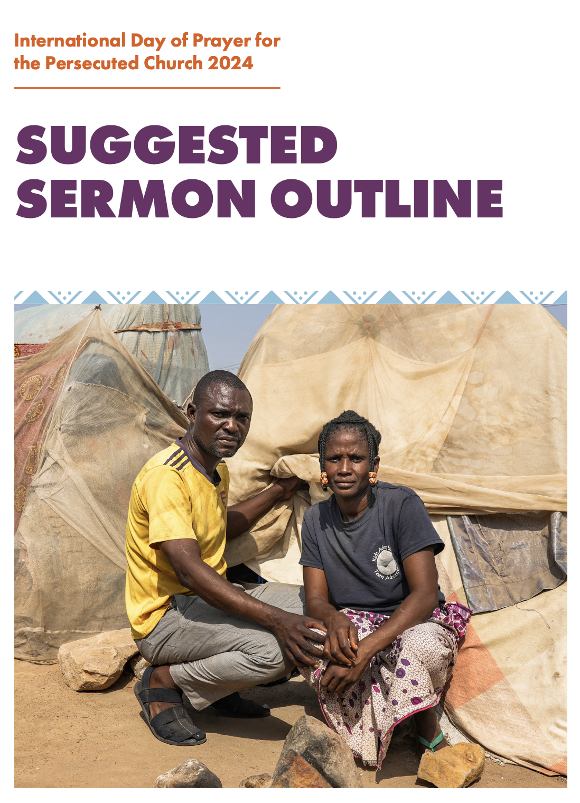

Preparation

For this IDOP session, you will need:

- Video projection with sound.
- If video is not available, but quotes are read out, different members of the congregation
could read these.
- Screen to display text of call and response prayer and images of those being quoted.

SUGGESTED SERMON OUTLINE

Scripture

⁶‘Is not this the kind of fasting I have chosen:
to loose the chains of injustice
and untie the cords of the yoke,
to set the oppressed free
and break every yoke?
⁷Is it not to share your food with the hungry
and to provide the poor wanderer with shelter –
when you see the naked, to clothe them,
and not to turn away from your own flesh and blood?

⁸Then your light will break forth like the dawn,
and your healing will quickly appear;
then your righteousness will go before you,
and the glory of the Lord will be your rear guard.

⁹Then you will call, and the Lord will answer;
you will cry for help, and he will say: Here am I.”

- ISAIAH 58:6-9

Introduction

Welcome to the International Day of Prayer for the Persecuted Church, 2024 – IDOP.

This period is known as All Hallow Tide, when churches remember the martyrs and saints of the Christian faith. Around the world some 100,000 congregations will be joining with us in celebrating the International Day of Prayer for the Persecuted Church. And this year our focus is on the displaced.

Video

To help us to see, to understand, to pray; to help us to walk a mile in the footsteps of our persecuted brothers and sisters in Sub-Saharan Africa, let us see them and hear their voices.

What they say is hard to hear, but they are our family, and we choose to listen.

Play IDOP Video
OR (where video playback is not possible)
quotes from the persecuted - delivered by different members of the congregation

MAGDALENE
‘Life has become so difficult for me. If I sit, I keep crying. If I lay down at night, everything that happened, I see it happen again. Like a movie, it all flashes in front of my eyes. Again, and again. The way they killed that boy. The moment when I saw that baby, still crying, in the fire.’

PASTOR ELISHA
‘They took my Bible, they took everything. They opened the Bible, and they [defecated] on the Bible. And they even videoed it and posted it. It pained me too much.’

MAFULUL
‘By 5pm the attackers came. They started shooting everywhere. My wife had just finished cooking. Immediately they started killing the women and children. They shot the ones who ran. They macheted the ones who stopped. It was then they killed my wife.

‘She carried our 9-month-old son on her back. When I went to the river, I found her on the ground. She was shot in the stomach. The bullet went through her body into our son on her back.

‘I saw them there. I cried. I cried. It was so hard. I turned and saw my brothers’ wife with two of their children. All of them dead on the ground. 20 people were killed instantly. And about 45 were injured.’

After Video/quotations

Powerful. Painful. Hard to hear. Yet today we choose to watch and pray in the hour of their Gethsemane, that they will not be overwhelmed. And neither, by the grace of God, will we.

Context
There are more Christians in Africa than in anywhere else in the world. And yet, according to recent research from Open Doors, 95 percent of the Christians killed in 2023 for their faith were murdered in Sub-Saharan Africa – and that is a conservative estimate. The vast majority were killed in Nigeria.
The violence is driving many from their homes: 34.5 million in Sub-Saharan Africa. And of these, more than 16 million are Christians.
That could be you and me, if we happened to live there rather than here.
And many of them are driven from their homes and off their ancestral land because of their faith in Jesus.
Islamist terror groups, such as Al-Qaeda, al-Shabab and Boko Haram are active. Islamist insurgency is the root cause of the violence and mass displacement.
Their aim is to forge an Islamist State, ruled by Islamic law. And they are doing so by force. So their primary target is Christians and non-Muslims. Though they also attack moderate Muslims who do not share their radical ideology.
Burkina Faso has lost 40 per cent of its territory to these Islamist terror groups. They have destroyed more than 6,000 schools, depriving a million children of education, laying up trouble for the years to come.
In Nigeria, Christian communities and villages are attacked and overrun by militants. We heard the stories of a few of those they attacked earlier. And it is happening almost daily. In Nigeria, the Islamist insurgents are moving south, deeper into Christian-majority areas.
Illia Djadi of Open Doors sums it up: ‘In some areas of Nigeria, going to church is like travelling with a one-way ticket. There's no certainty or guarantee of coming back. But people are still going to church.’

Impact
The chaos and disruption are impacting the Church, communities and the world.
A church leader in Burkina Faso was advised to leave because of the rising violence. But he could not abandon his church and his congregation.
His church was attacked in April 2019. Well-armed Islamist insurgents came with a list of targets. His name was top of that list. They tried to force him to convert to Islam. When he refused, they killed him. Along with five other leaders in the church.
In Nigeria, Fulani extremists are targeting Christian communities, burning churches and forcing villagers off lands that have belonged to them for generations.
Pastor Barnabas in Nigeria is just one of the displaced. His brother and his brother’s wife were killed by militants. All he could do was run. And when they caught him too, they set about him with a machete and a stick. Even now, he can barely use one hand.
[You may play Pastor Barnabas’ video]
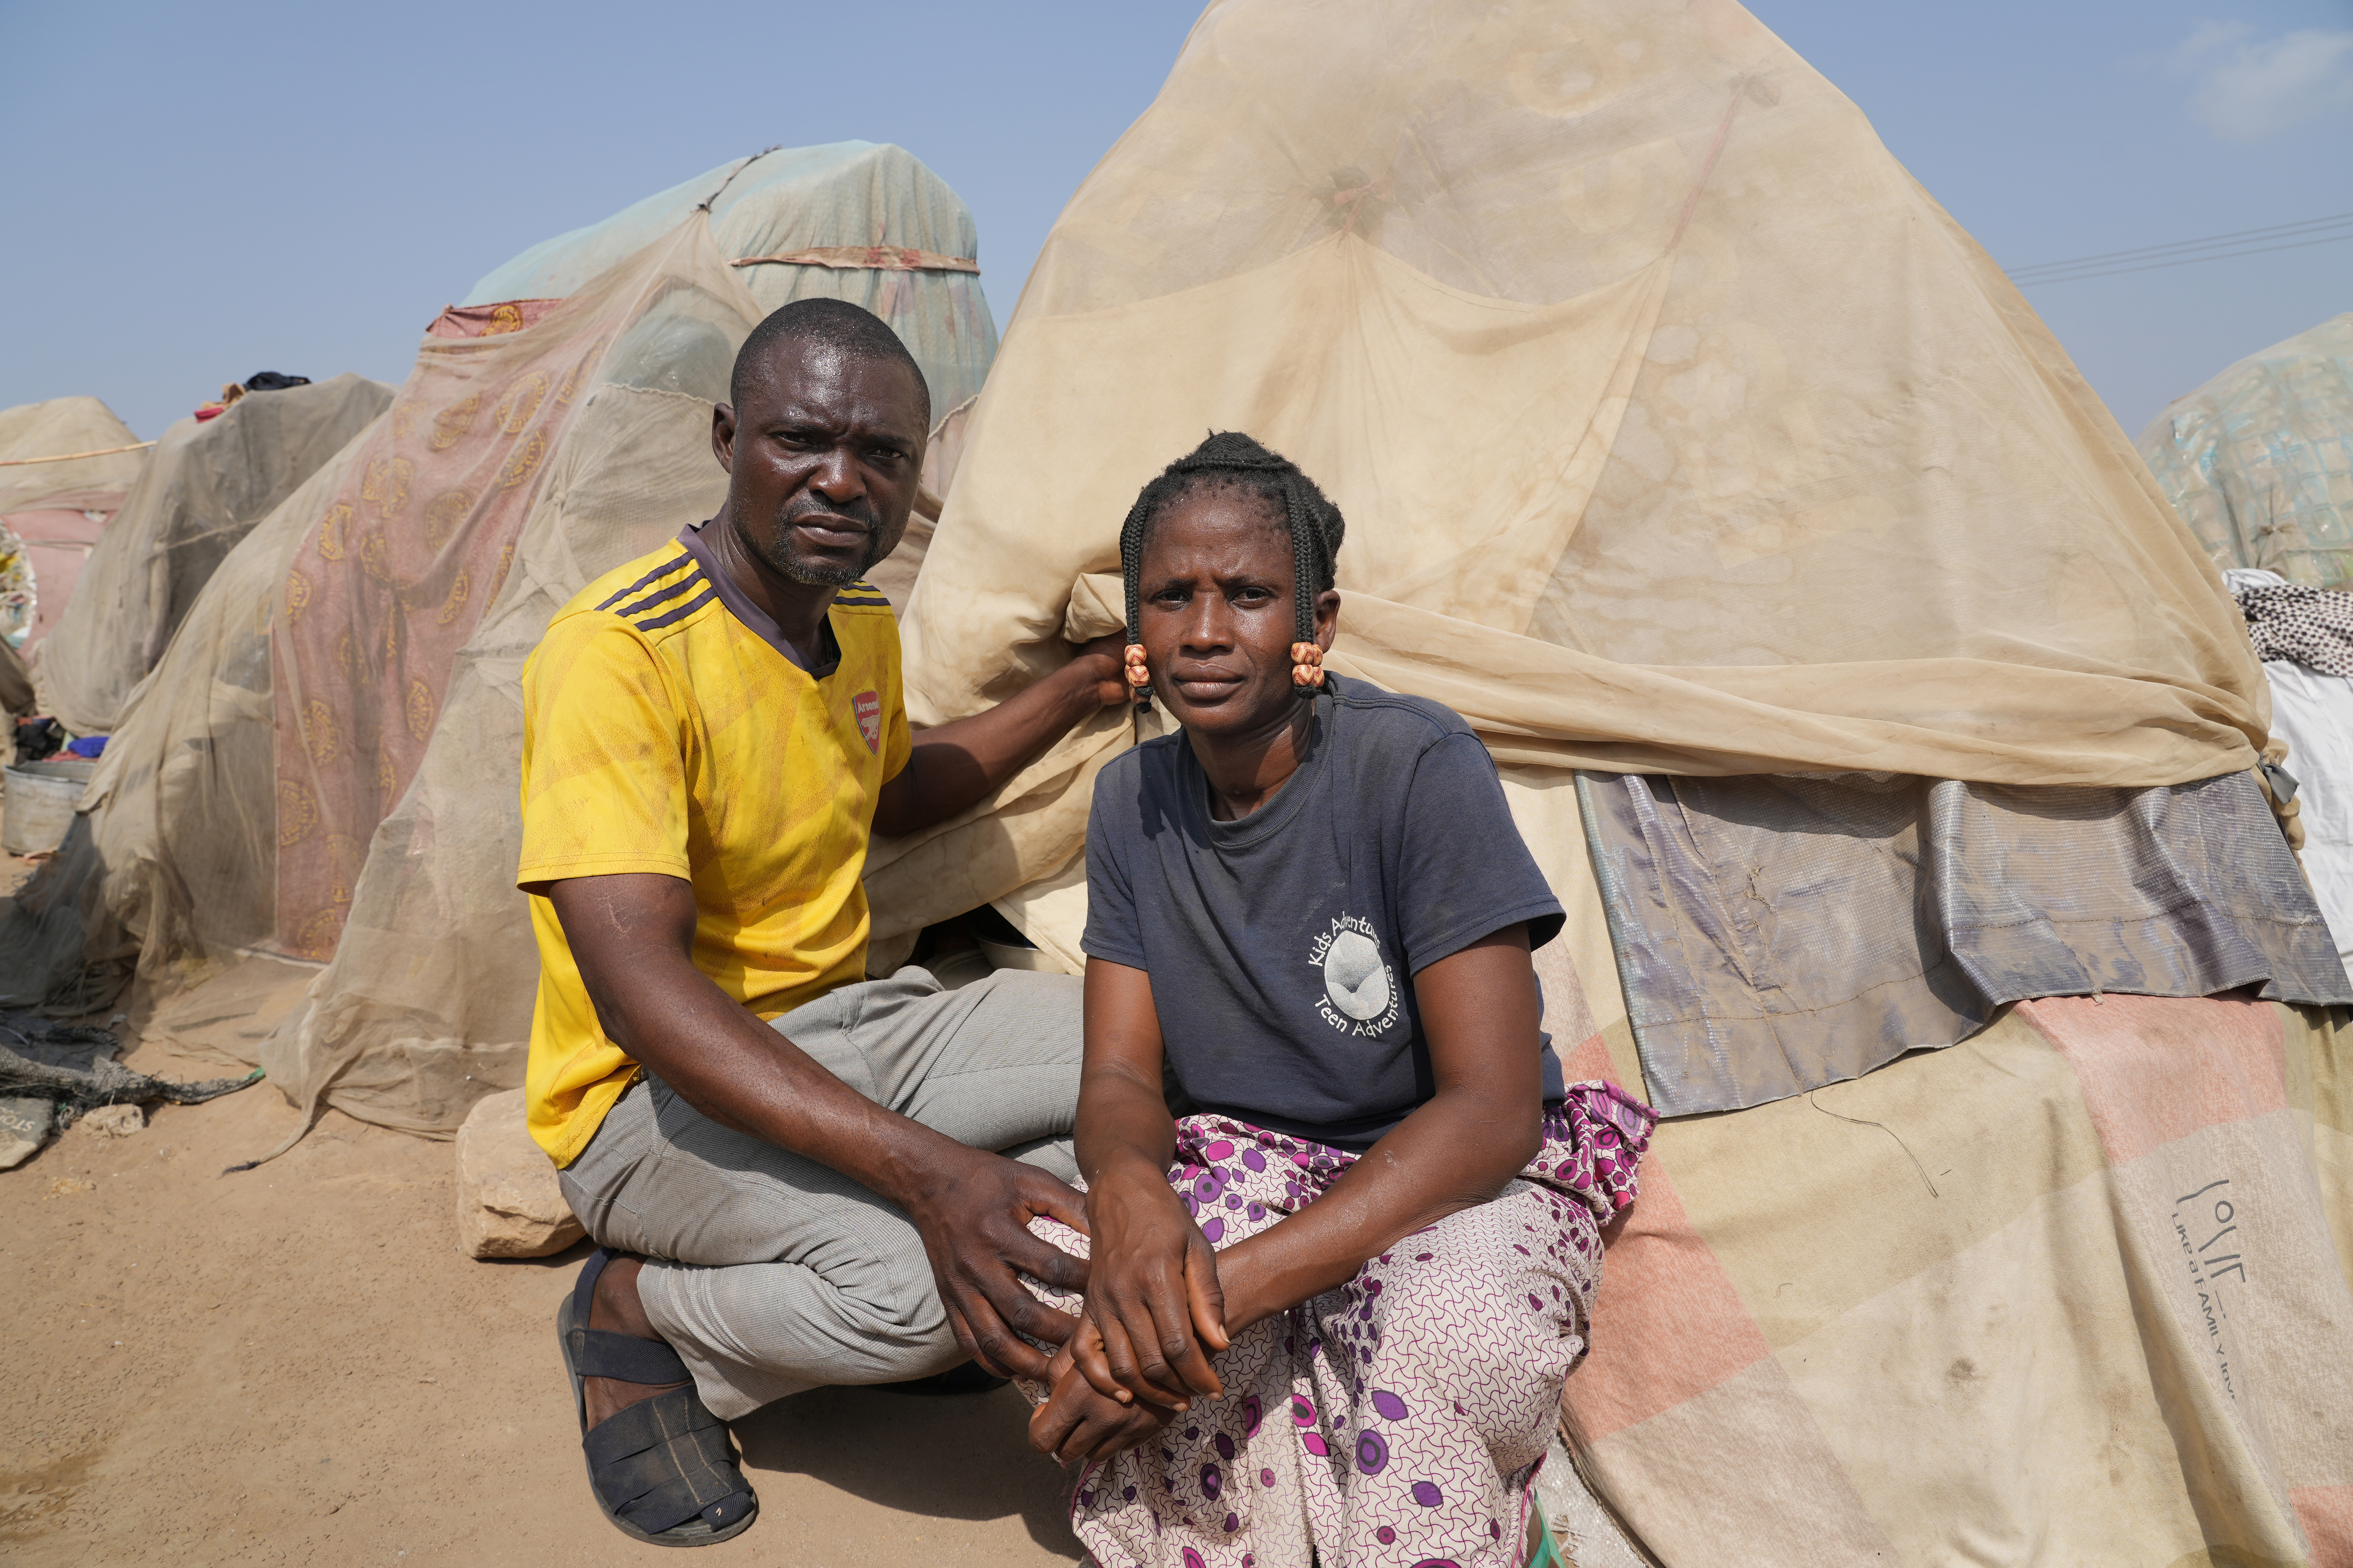
For almost five years, Barnabas has been living in a camp with his wife and five children. Together, they share a tent affording less floorspace than a double mattress. And they are surrounded by others having to do the same. Barnabas is their pastor and his frustration is palpable:
‘The news doesn’t care about it,’ he says, ‘the government doesn’t talk about it. Nobody talks about it. We are remaining in darkness. Tell me: How that would make you feel? Being forgotten, being disregarded?
‘Everything in my home and village was burned,’ he adds. ‘I cannot take care of my children. I cannot feed them. They are no longer in school. I have lost everything.’
Except his faith.
‘I hand over everything to God,’ he says. ‘Let the will of God be done in my life.’
Working with nothing but his faith, he does all he can to help the believers in his camp.
‘I will not lose my confidence in God. And I will always encourage them, no matter what, that they should still believe God, that one day we shall come back to our ancestral homes. The battle belongs to the Lord. Our eyes and our hope are on Him.’
Hope. God is the God of hope. And Barnabas clings to Him.
Insecurity and instability are putting the future of the church at risk and creating a displacement crisis, an education crisis and a healthcare crisis.

Abandonment
Across Sub-Saharan Africa, as conflict kills and displaces Christians, many have a strong feeling of being abandoned. Alone.
And yet…
The Church in Africa is among the fastest growing in the world. And across Nigeria, within sight of communities destroyed by violence, many new churches are springing up. A Church strong, resilient, faith-filled and determined.
‘We are hard pressed on every side, but not crushed; perplexed, but not in despair; persecuted, but not abandoned; struck down, but not destroyed.’
– 2 Corinthians 4:8-9

Scriptural Mandate
Our Scriptural mandate is clear. God is calling and we will respond.
[If you can, please display the words of Isaiah 58:6-9 along with the response on a screen.]
Call:
Is not this the kind of fasting I have chosen:
to loose the chains of injustice
and untie the cords of the yoke,
to set the oppressed free
and break every yoke?

Response:
Lord, we will work for justice, until the oppressed are set free.

Call:
Is it not to share your food with the hungry?

Response:
Lord, we will share our food with the hungry.

Call:
And to provide the poor wanderer with shelter?

Response:
Lord, we will provide shelter for the homeless.

Call:
When you see the naked, to clothe them?

Response:
Lord, we will give clothes to those who have none.

Call:
And not to turn away from your own flesh and blood?

Response:
Lord, the body of Christ is our flesh and blood. We will not turn away.
All humanity is made in your image.
To turn away from others would be to turn away from you.

Call:
Then your light will break forth like the dawn,
and your healing will quickly appear;
then your righteousness will go before you,
and the glory of the Lord will be your rear guard.
Then you will call, and the Lord will answer;
you will cry for help, and he will say: “Here am I.”

Response:
Lord, you will help us as we help others in need.
Open our eyes, open our hearts and open our hands.

Call to Action
Christians targeted by violence in Sub-Saharan Africa want us to know that they are feeling Isolated and alone.
And only when we share their pain, will they no longer feel alone.
The charity Open Doors has a vision to awaken the global Church to their need.
They have a vision to bridge divisions of culture, language and geography, to connect the African Church to the global Church.
Their aims are to help the global community acknowledge and act against extreme violence.
To meet the basic needs of Christians driven from their homes by conflict and war.
For every family in Sub-Saharan Africa who has been directly affected by violence to be supported, spiritually, physically, and emotionally.
To support the church, to help it persevere, be resilient, resourceful and influential.
It aims to raise a million prayers and signatures on a petition.
Open Doors invites you to sign the petition. And to share that petition. You can visit the Open Doors website for more details and to take action.
John Ugbede is the Vice-Chairman of the Christian Association of Nigeria in Benue state. Two million Christians in Benue alone have been driven by conflict into 13 separate camps for the displaced.
He says: ‘The fact is we are under attack. The fact is millions are displaced from their ancestral homes.’
And he calls on us to see, to care and to help:
‘Rise up to our support. Rise up to tell the world that something is wrong. Rise up for the Church. Stand with them because we are one. We are believers in Christ, the living and risen God. We are one so they should stand with us. Tell everybody, tell the powers that be that the Church is under persecution, and they must be rescued. I believe that if that happens, we will be delivered.’

Power of prayer
This is a Day of Prayer, so we will pray. Prayer is the first faltering step towards love in action.
There is power in prayer. Those who have shared their stories with us know that. They depend on that.
PASTOR BARNABAS, NIGERIA:
‘My prayer for you is that God Almighty will remember you the way others have remembered us. May God Almighty strengthen you the way they strengthened us.’

JONATHAN UGBEDE, NIGERIA:
‘First and foremost, we need prayer. We need the body of Christ worldwide to come and stand with us. God will not abandon us. God is hearing our prayers. And God will surely respond.’

PASTOR SORÉ, BURKINA FASO:
‘Prayer really comforted me. Your gifts and prayers are so important to start healing the wounds of displacement. Though we are displaced, Jesus is not. He will never be displaced from our lives.’
[You may play the video of Pastor Soré]

ILLIA DJADI, OPEN DOORS:
‘When we pray, miracles happen.
‘Pray, but also support aid agencies and other organisations working on the ground, providing relief materials, the much-needed support for displaced people, for the victims of the violence.
‘In addition to that, stand and take a position. Put pressure on governments, MPs, political leaders, to do the right things, to take a stand, because they have a duty to protect.’
We will pray together, as a congregation, into the bigger picture, then we will pray for individuals in twos and threes.

SUGGESTED CORPORATE PRAYER:
Father, we pray for the violence to end. Speak to the men of violence and quicken their hearts. Show them a better way. Show them yourself, Jesus, the Way, the Truth, and the Life. And lead them in your way.
Father, we pray for political leadership. For hearts of compassion; for the will, the strategy and the resources to put an end to impunity, and to protect their people.
For international agencies to wake up to the religious dimension of this assault on Africa’s Christians.
That they will engage not only with politicians, but with the faith leaders who are respected and trusted by the people.
We pray for those in leadership in the Church. Many wonder how to respond. Give them wisdom. Give them guidance. Give them resources.
Father, we pray for our brothers and sisters in Christ. We declare your goodness and we cry out to you to deliver them from evil.
Protect them, provide for them, and strengthen them in their faith. And help us to do the same.
Comfort the many who mourn. Grant them beauty instead of ashes, the oil of joy instead of mourning. Dress them in a garment of praise instead of despair. Raise them up to be oaks of righteousness, a planting of the Lord for the display of Your splendour.
Help your beloved body to persevere, to grow in resilience, endurance and determination. To continue in faithfulness. And help us to do the same.
Help us also to choose to watch and pray and to stand with our brothers and sisters in this their time of trial.
Our Christian family is paying a price for their faith. To echo the words of Illia Djadi of Open Doors: ‘Are we ready to pay that price? We have freedom, we have protection, we have everything. Are we ready to pay that heavy price for our faith?’

Please make your personal response to that, right now, to the Lord.

GUIDELINES FOR SMALL GROUP PRAYER:
Please join with one or two beside you to pray.
For those like Magdalene, Pastor Elisha, Mafulul and Pastor Barnabas, who have lost everything and who have opened their hearts to tell us their stories.

Picture yourselves standing with your arms around them. Draw them close and pray for these, your brothers and sisters who are suffering for their faith.

Hebrews 13:3 (paraphrase) ‘Remember them as if you yourselves were with them; those who are mistreated, as though you yourselves were suffering.’

ABOUT OPEN DOORS
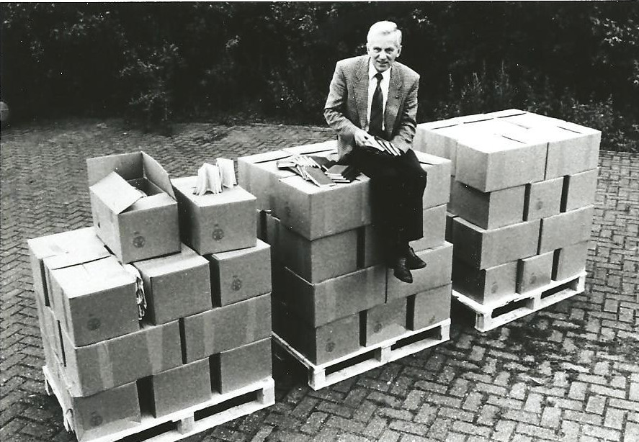

It was back in 1955 that a young Dutch missionary went to Communist Poland with a suitcase full of gospel tracts. Behind the Iron Curtain, he found isolated Christians who thought the world had forgotten them, and churches desperately in need of Bibles.

He prayed and opened his Bible – and found these words: “Wake up! Strengthen what remains and is about to die.” Revelation 3:2

That man became known as Brother Andrew, that verse became his mission – and his trip changed the world.

Brother Andrew founded Open Doors and made countless journeys across Europe, smuggling Bibles in his blue VW Beetle.

As the ministry grew, other needs emerged. As well as Bibles, persecuted Christians around the world needed leadership, education, practical support.

Today, your support means Open Doors works in more than 70 countries to support Christians who dare to follow Jesus no matter the cost. With your gifts and prayers, millions of persecuted believers know they are not alone. Thank you for standing with them.

What is the persecuted church?

We define it as: Christians who live under or who face discrimination, restriction and persecution because of their faith in Jesus.
Every year, Open Doors produces the ‘World Watch List’ of the 50 most dangerous places to follow Jesus. The list reveals an uncomfortable truth: one in seven Christians around the world are persecuted for their faith.
Persecution has two forms. ‘Smash’ includes violence and even killing. ‘Squeeze’ includes pressure, exclusion, discrimination and severe restriction on freedom.

ABOUT ARISE AFRICA
A global campaign to stop the violent persecution in Sub-Saharan Africa, and start the healing.

WHAT’S THE PROBLEM?
Christians in Sub-Saharan Africa are being persecuted on a scale never seen before. Murder, torture and kidnapping are an everyday threat. Islamist extremists are using unprecedented violence.

As a result, 16 million Christians have been driven from their homes across the region. But nobody is talking about it and too few people are tackling the problem – and our persecuted brothers and sisters feel abandoned.

HOW DID ARISE AFRICA COME ABOUT?
African church leaders have come together to ask you, the global church, to stand with them against violent persecution.

“The fact is, we are under attack,” says Jonathan Ugbede, a church leader in Benue, Nigeria. “Millions are displaced from their homes. It’s time to rise up to our support. Rise up to tell the world something is wrong. Rise up for the Church.”

WHAT’S THE AIM OF ARISE AFRICA?
Arise Africa aims to:
- Provide spiritual, emotional and physical support to four million believers by 2027
- Raise a million prayers and petitions
- See a resilient, resourceful and influential church in Sub-Saharan Africa

Our global petition calls on international communities to ensure Christians and other vulnerable individuals in Sub-Saharan Africa are treated with dignity and respect by:

1. Providing robust protection from violent militant attacks
2. Ensuring justice through fair prosecutions of the attackers
3. Ensuring restoration to bring healing to affected communities

Arise Africa is a campaign run by Open Doors in partnership with the Association of Evangelicals in Africa, among others.

“ARISE, SHINE, FOR YOUR LIGHT HAS COME.”
Isaiah 60:1

